 | English 4 Skills (PEIC, UK)  Pearson English International Certificate (PEIC, UK) — English 4 Skills at Myanmar New Era Academy: listening, speaking, reading, and writing with grammar and writing support, leading to an international certificate.  Take free placement test
Program Overview: English 4 Skills (PEIC, UK) welcomes learners from age 6 through students who have completed Grade 12. Classes run on Saturdays and Sundays so students can continue regular school. The June intake uses an upgraded curriculum with extended teaching hours. Every learner takes a free Level Test to join the right class level. MNEA is a Pearson Edexcel Approved Centre — you can sit the PEIC exam in Nay Pyi Taw and receive an internationally recognised certificate when you pass.
Who Should Join: Children from age 6 through students who have finished Grade 12 — placement by free Level Test.
Program highlights:
- Listening, speaking, reading & writing including grammar & writing
- Individual strengths and needs tracked for steady progress
- Communication, teamwork & critical thinking in learning activities
- Volunteer experience opportunities for older students
- Visible progress after each level; regular parent discussions

Program Details, Levels & Promotions
Programme :Pearson English International Certificate (PEIC, UK) — English 4 SkillsJune 2026
intake
Centre :Pearson Edexcel Approved Centre — MNEA, Nay Pyi Taw
Duration :7 monthsJune – December 2026
Starting Date :1 June 2026
Class Days :Saturday & Sunday
Subject Focus :English — 4 skills (listening, speaking, reading, writing)Including grammar &
writing support
Total Class Hours :140 hours + 10 bonus hoursBonus period: 18 May – 26 May 2026
Age / Stage :From age 6 through students who have completed Grade 12
Placement :Free Level TestYou are placed in the class level that fits you best
June Intake :Upgraded curriculum and more teaching hours while you continue regular school
Certification :PEIC (UK) exam in Nay Pyi TawInternationally recognised certificate when you
pass

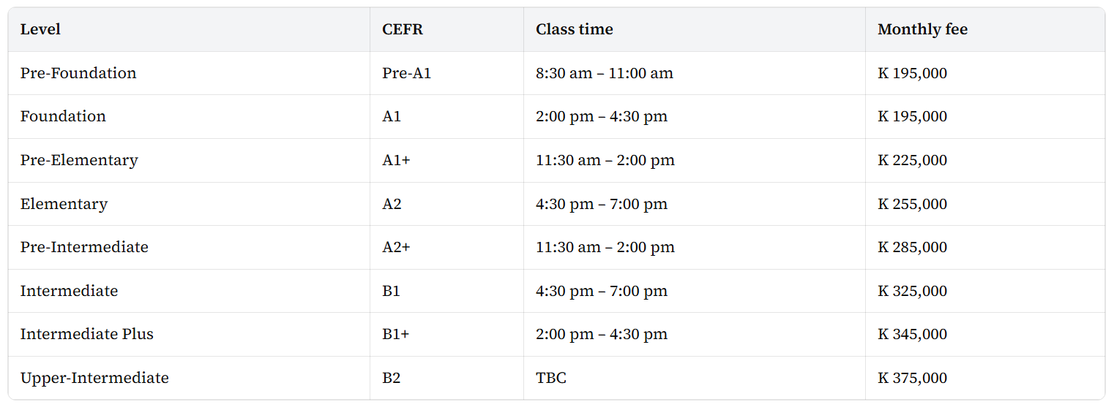
Special Promotions :Enrol / pay before 7 May 2026 — 10% off + extra 10 hours
Before 15 May 2026 — 3% off + extra 10 hours
Full payment — additional 5% off
Two instalments — additional 3% off
Two or more students (or courses) — additional 5% off
Referral — additional 5% off
Current MNEA students — additional 5% off
Key Benefits of Program
- All four skills with grammar & writing support
- Personal monitoring so each learner keeps improving
- 21st-century skills: communication, teamwork, critical thinking
- Volunteer options for older students
- Progress you can see after every level; parent meetings each level
- Pearson Edexcel Approved Centre; sit PEIC in Nay Pyi Taw
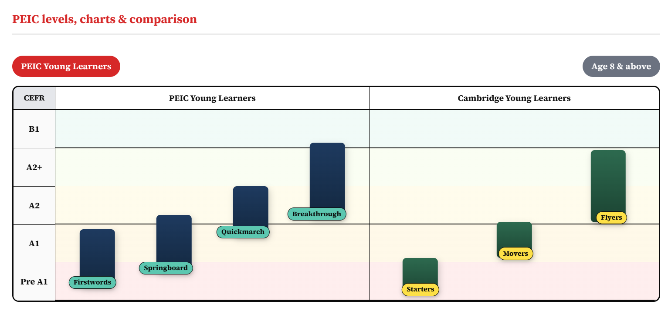
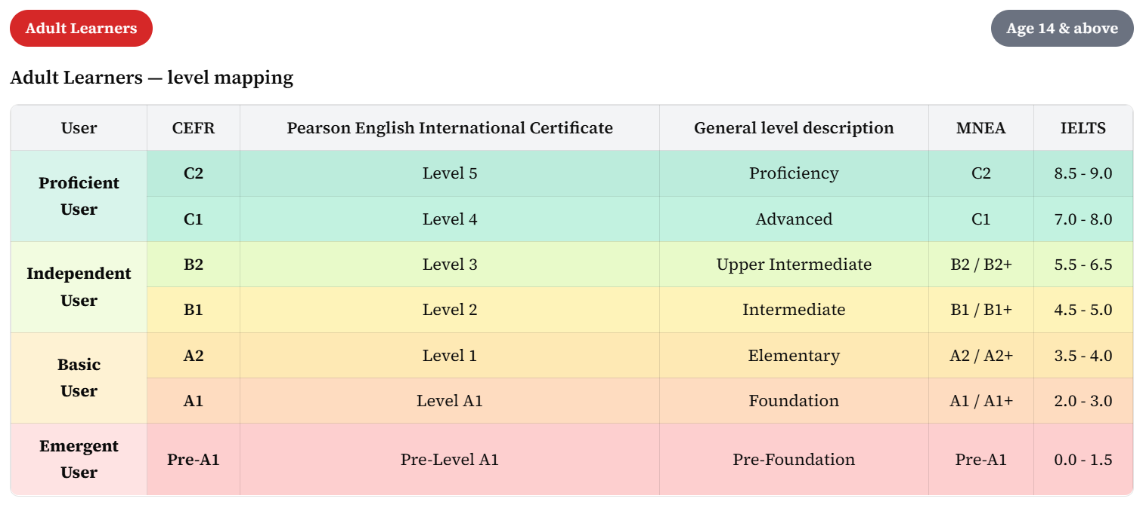
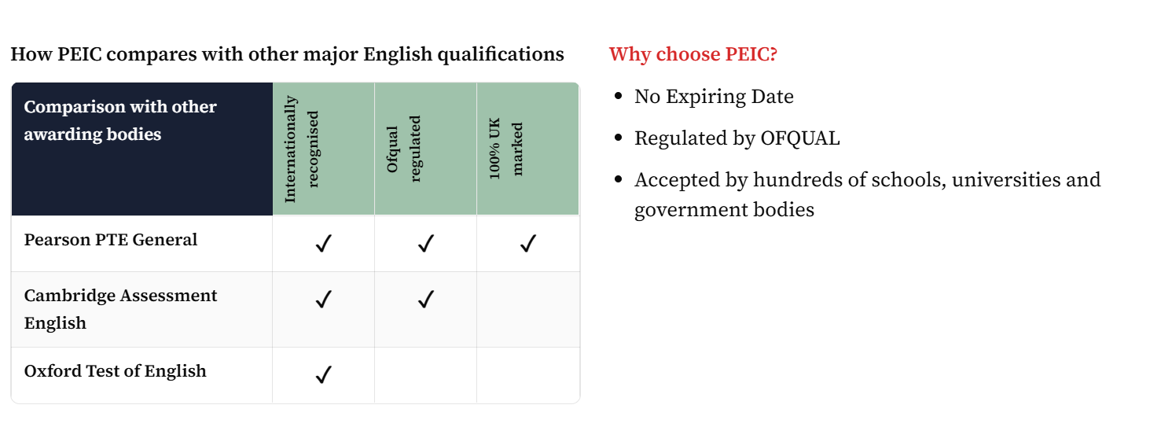

Take free placement test

